*AWS*

*EC2*

1. Is Amazon EC2 IaaS or PAAS?
2. What is AWS EC2?
3. What is an instance in Amazon EC2?
4. How instances are categorized in AWS EC2?
5. What is On-Demand Instances in AWS EC2?
6. What is Reserved Instances (RI) in AWS EC2?
7. What are the categories of Reserved Instances in AWS?
8. What is Spot instances in AWS EC2?

##### **Route 53**

A DNS web service

##### **Simple E-mail Service (SES)**

It helps you to send email using either a RESTFUL API call or a regular SMTP.

##### **Identity and Access Management (IAM)**

It provides enhanced security and identity management for your AWS account

##### **Simple Storage Device (S3)**

It is a storage device and the most widely used AWS service

##### **Elastic Block Store (EBS)**

It offers persistent storage volumes that attach to EC2 to allow you to persist data past the lifespan of a single Amazon EC2 instance.

##### **AWS Lambda**

Serverless Computing

##### **CloudWatch**

To monitor AWS resources, It allows administrators to view and collect key Also, one can set a notification alarm in case of trouble.

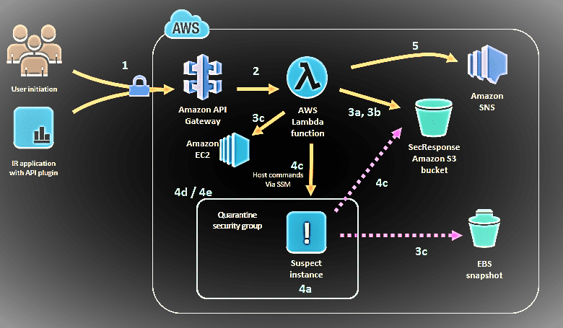

# *AWS Lamda*

1. What is AWS Lamda?
2. What limitations apply to AWS Lambda function code?
3. What events can trigger an AWS Lambda function?
4. What can trigger an execution of the Lambda function?
5. What are the factors that decide how AWS Lambda is charged?
6. What's AWS Lambda's best language?
7. What are different ways to trigger Lamda?